Kingdom of Saudi Arabia  Ministry of Education  Hafr Al Baten Educational Directorate for boys  Tarbeat Al –Ajial International Schools |  |  |  |    |  |  | Date: 2025 / 10 / 27  Subject: Computer  Class.: 6  Time: 40 minutes
……………… |  | Seat Number |  | ……………………………………….. |  |  |  | Student’s Name
Mid-Term Exam (1st Semester) 2025/2026
Sign. | Consultative Name |  | Sign. |  | Corrector’s Name | Marks in letters |  |  | Marks  in numbers
 |  |  |  |  |  |  |  |  | 20

Q1: Read and file in the blanks:

- The dimensions of an A4 size paper are
21.0 cm | 29.7cm
21.0 cm

29.7cm

Q2: write the correct name of each part:
Stop Sign | Calculator | No Call | Smart watch | Shopping Cart
Smart TV | Wash Hands | CLI | Vector | Gift

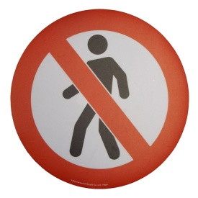 | …………………………  Stop Sign  …………………………  ………………………… | 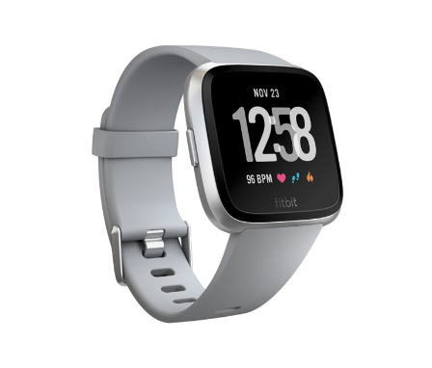 | …………………………  …………………………  Stop Sign  …………………………
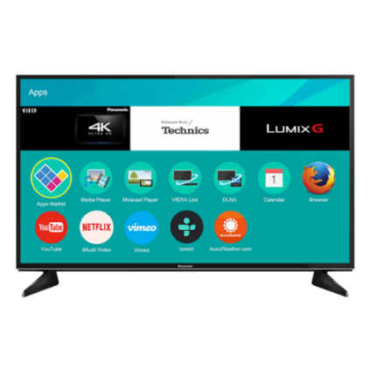 | …………………………  Smart TV  …………………………  ………………………… |  | …………………………  …………………………  Stop Sign  …………………………
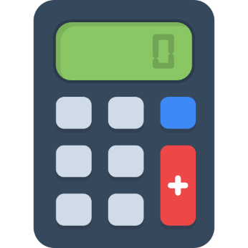 | …………………………  …………………………  Stop Sign  ………………………… |  | …………………………  …………………………  …………………………  Stop Sign
 | …………………………  …………………………  Stop Sign  ………………………… |  | …………………………  …………………………  Stop Sign  …………………………
 | …………………………  …………………………  Stop Sign  ………………………… |  | …………………………  …………………………  Stop Sign  …………………………
Good Luck

